1.
import java.util.Scanner;
import java.io.*;
public class pgm
{
public static void main(String[] args)
{
Scanner scan=new Scanner(System.in);
int t=scan.nextInt();
for(int i=0;i<t;i++){
long n=scan.nextLong();
System.out.println(n+" can be fitted in");
if(n>=-128 && n<=128)
System.out.println("byte");
if(n>=-32768 && n<=32767)
System.out.println("Short");
if(n>=-2147483648L &&n<=2147483647L)
System.out.println("int");
if(n>= -9223372036854775808L && n<=9223372036854775807L)
System.out.println("long");

}
}
}

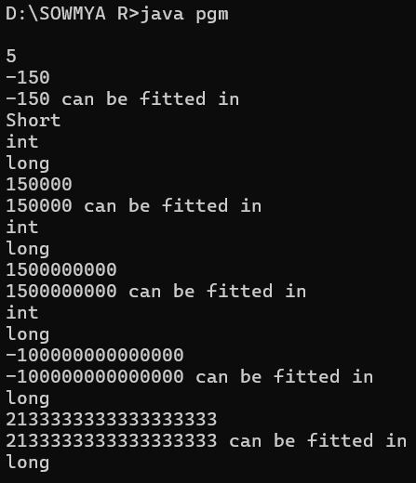
2.
import java.io.*;
import java.util.Scanner;

public class pgm
{
public static void main(String[] args)
{
Scanner scan= new Scanner(System.in);
int cents=scan.nextInt();
double dollar=cents/100.00;
System.out.format("The output be: %.2f",dollar);
}
}

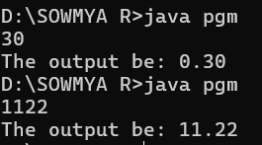

3.
import java.io.*;
import java.util.*;
public class pgm
{
public static void main(String args[])
{
Scanner number = new Scanner(System.in);
System.out.println("Enter player's Score:");
double n = number.nextDouble();
int a = (int)n;
System.out.println("Score:"+a);
}
}

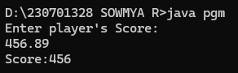
4.
import java.io.*;
import java.util.Scanner;

public class pgm
{
public static void main(String[] args)
{
Scanner scan= new Scanner(System.in);
int sal=scan.nextInt();
double per=scan.nextDouble();
double n=sal*(per/100);
double ans=sal+n;
System.out.println("The new Salary: "+ans);
}
}
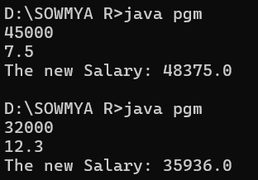\
5.
import java.util.Scanner;
import java.io.*;
public class pgm
{
public static void main(String[] args)
{
Scanner scan= new Scanner(System.in);
int n=scan.nextInt();
int temp=n;
int rev=0,rem;
while(n!=0)
{
rem=n%10;
rev=rev*10+rem;
n=n/10;
}
if(rev==temp)
{
System.out.println("The reversed number is "+rev+". It is the same as the original.");
}
else
{
System.out.println("The reversed number is "+rev+". It is not the same as the original.");
}
}
}

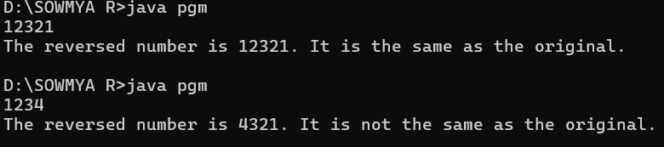
6.
import java.io.*;
import java.util.*;
public class pgm
{
public static void main(String[] args)
{
Scanner num=new Scanner(System.in);
System.out.println("Enter valuee:");
int number=num.nextInt();
int m, n;
for (m = 1; m <= number; m++)
{
for (n = 1; n <= number - m; n++)
{
System.out.print(" ");
}
for (n = 1; n <= m * 2 - 1; n++)
{
System.out.print("*");
}
System.out.println();
}
for (m = number - 1; m > 0; m--)
{
for (n = 1; n <= number - m; n++)
{
System.out.print(" ");
}
for (n = 1; n <= m * 2 - 1; n++)
{
System.out.print("*");
}
System.out.println();
}
}
}
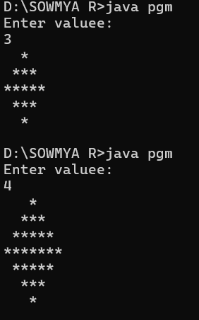
7.
import java.io.*;
import java.util.*;
public class pgm {
public static void Pascal(int n)
{
for (int i = 1; i <= n; i++) {
for (int j = 0; j <= n-i; j++) {
System.out.print(" ");
}
int a = 1;
for (int k=1; k<=i; k++) {
System.out.print(a + " ");
a = a* (i - k) / k;
}
System.out.println();
}
for (int i =n-1; i>0; i--) {
for (int j = 0; j <= n - i; j++) {
System.out.print(" ");
}
int a= 1;
for (int k = 1; k <= i; k++) {
System.out.print(a + " ");
a = a * (i - k) / k;
}
System.out.println();
}
}
public static void main(String[] args)
{
Scanner num=new Scanner(System.in);
System.out.println("Enter Value:");
int n =num.nextInt();
Pascal(n);
}
}
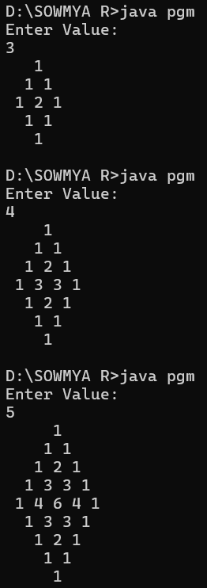
8.
import java.util.Scanner;
import java.io.*;
public class pgm
{
public static void main(String[] args)
{
Scanner scan=new Scanner(System.in);
int q=scan.nextInt();
for(int i=0;i<q;i++)
{
int a=scan.nextInt();
int b=scan.nextInt();
int n=scan.nextInt();
int sum=a;
for(int j=0;j<n;j++)
{
sum+=(int) Math.pow(2,j)*b;
System.out.print(sum+" ");
}
System.out.println();
}

}
}
